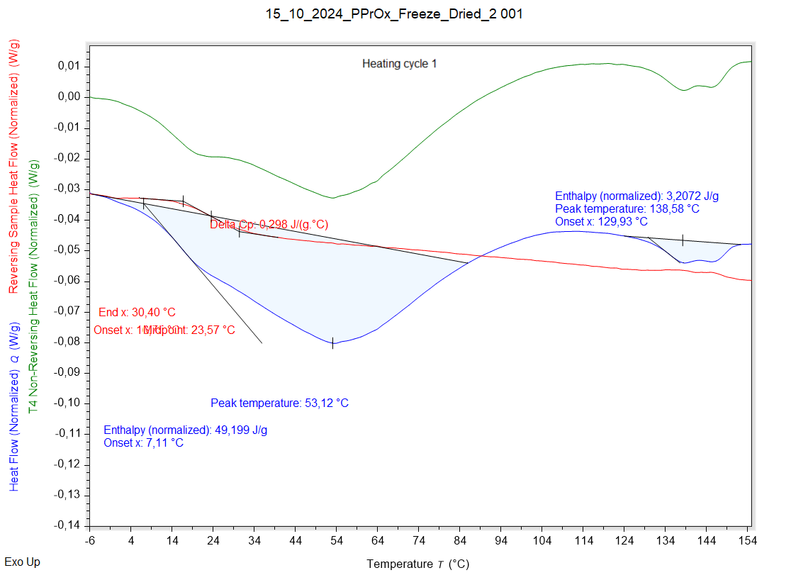

|  |  |  |  |
| --- | --- | --- | --- |
| Solvent evaporation | Solvent evaporation onset (°C) | Solvent evaporation peak (°C) | Solvent evaporation enthalpy (J/g) |
|  | 7,113 °C | 53,116 °C | 49,199 J/g |

|  |  |  |  |
| --- | --- | --- | --- |
| Melting | Melting onset (°C) | Melting peak (°C) | Melting enthalpy (J/g) |
|  | 129,927 °C | 138,582 °C | 3,2072 J/g |

|  |  |  |  |
| --- | --- | --- | --- |
| Glass transition | Glass transition onset (°C) | Glass transition endpoint (°C) | Glass transition midpoint (°C) |
|  | 16,751 °C | 30,405 °C | 23,573 °C |

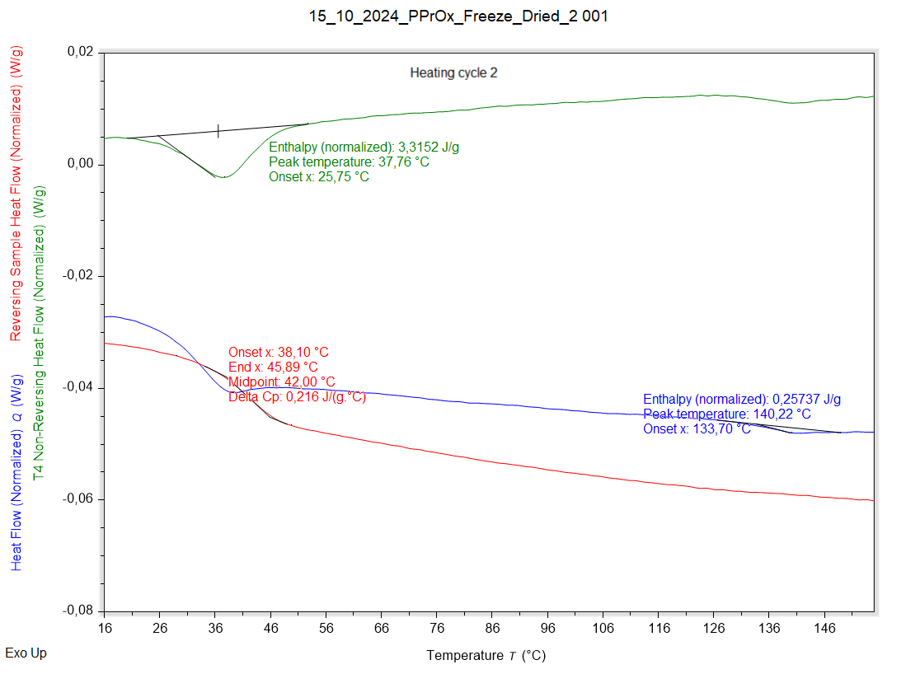

|  |  |  |  |
| --- | --- | --- | --- |
| Solvent evaporation | Solvent evaporation onset (°C) | Solvent evaporation peak (°C) | Solvent evaporation enthalpy (J/g) |
|  | 25,746 °C | 37,760 °C | 3,3152 J/g |

|  |  |  |  |
| --- | --- | --- | --- |
| Melting | Melting onset (°C) | Melting peak (°C) | Melting enthalpy (J/g) |
|  | 133,701 °C | 140,218 °C | 0,25737 J/g |

|  |  |  |  |
| --- | --- | --- | --- |
| Glass transition | Glass transition onset (°C) | Glass transition endpoint (°C) | Glass transition midpoint (°C) |
|  | 38,096 °C | 45,885 °C | 41,998 °C |